Title: Genomic analyses reveal distinct evolutionary pattern of ducks and identify genetic changes underlying domestication and speciation
Rui Liu^{1,*}, Weiqing Liu^{2,3,*}, Enguang Rong¹, Xiaoxue Wang¹, Lizhi Lu⁴, Huifang Li⁵, Li Chen⁴, Yong Zhao^{3,6}, Huabin Cao⁷, Wenjie Liu¹, Chunhai Chen¹, Guangyi Fan^{2,6,8}, Weitao Song⁶, Huifang Lu³, Yingshuai Sun³, Wenbin Chen^{2,9}, Xin Liu^{2,6,9}, Xun Xu^{2,6,9}, Yinhua Huang^{1,#}, Ning Li^{1,#}
¹State Key Laboratory for Agrobiotechnology, China Agricultural University, Beijing, 100094, China. ²BGI-Shenzhen, Shenzhen 518083, China. ³BGI-Wuhan, Wuhan 430075, China. ⁴Institute of Animal Sciences and Veterinary Medicine, Zhejiang Academy of Agricultural Sciences, Hangzhou 310021, China. ⁵Institute of Poultry Science of Jiangsu, Yangzhou 225125, China. ⁶BGI-Qingdao, Qingdao 266555, China. ⁷Jiangxi Provincial Key Laboratory for Animal Health, Institute of Animal Population Health, College of Animal Science and Technology, Jiangxi Agricultural University, Nanchang 330045, China. ⁸State Key Laboratory of Quality Research in Chinese Medicine, Institute of Chinese Medical Sciences, University of Macau, Macao, China. ⁹China National GeneBank-Shenzhen
*These authors contributed equally
#Corresponding authors: Y.H.H. (cauhyh@cau.edu.cn) or N.L.(ninglcau@cau.edu.cn)
Abstract
Domestic ducks were considered to be tamed from the mallard or the descendant of the mallard and the spot-billed duck. Domestic ducks showed remarkable phenotypic variation in morphology, physiology and behavior. However, molecular genetics for ducks’ origin and their phenotypic variation are still poorly studied.
Here we presented the mallard and the spot-billed genomes and performed whole-genome sequencing on eight domestic duck breeds and eight wild duck species. Surprisingly, Analyses on these data supports a model that domestic ducks diverged from their closely wild lineage (mallard duck and spot-billed duck) at the last glacial period (LGP, 100~300 kilo years ago (Kyr)). Wild lineage further speciated into mallard duck and spot-billed duck about 70 Kyr, whereas domestic lineage decreased their population size through the LGP. A scan of wild duck genomes by comparing with domestic duck genomes identified a number of locus that may have been affected by positive selection in ancestral wild ducks after their divergence from domestic lineages. Function analyses suggested that those genes usually affecting organs development and energy metabolism that may involving long-distance flight ability. Further selective sweep analyses identified two genes associated with egg production and three genes related to feeding modulation being under selection in domestic ducks. These analyses unravel a distinct evolutionary pattern of ducks and two wild duck de novo genomes also provide a novel resource for speciation study.

Significance
Recently, many researches have found that traditional domestication hypothesis is incompatible with genetic data. Moreover, why those domestic animals been domesticated and does the remarkable phenotypic variations between domestic and its closest wild relatives just mainly caused by domestic's genetic adaptations to human environment? For example, does domestic duck loss flight and migration ability during domestic process? Through reveal the evolutionary history of ducks, we demonstrate that both the traditional hypotheses on duck domestication are incompatible with our data. Instead, there is a very long divergence time between wild and domestic ducks, longer than the divergence time between mallard and spot-billed duck. The comparison between domestication and speciation process are also informative for understanding the genetic basis of biodiversity
Introduction
As two major concerns of evolutionary study, both domestication and speciation (or population divergence) benefited from the advance of sequencing technology(1-9). The genome assembly and characterizing of genetic variation in many domestic and wild animals have facilitated the revealing of their complex demographic history, which provides profound knowledges for both domestication and speciation studies (6-8, 10). We previously drew the draft of a Beijing duck genome and identified genomic variation within this assembly(11). However, as the most economical important waterfowl and one of the principal natural hosts of influenza A viruses, genetic variations of duck were not well characterized. And debates about domestic ducks being domesticated from the mallard duck or the descendant of mallard duck and spot-billed duck are still continuing.
Until now there are more than 140 wild duck species across the world and most of them can hybridize each other (12, 13). Phylogeographic structure of dabbling ducks using 5’-end sequencing of the mtDNA control region and ODC-6 of nuclear DNA demonstrated that the mallard duck diverged from its closely population (spot-billed duck) recently, implying they are good resource for speciation studies (14). Domestic ducks are considered to originated from East Asian and Europe and show broad phenotypic difference from these wild duck species, such as loss of flight and migration ability, reducing of brain size, increasing of body size and fertility(15-19). Previous studies based on similar outlooks habits and distributions provide two hypotheses about domestic ducks’ origin. One hypothesis suggested that domestic ducks were originated from the mallards, while the other argued that they were tamed from descents of the mallard (Anas platyrhynchos) and spot-billed (Anas zonorphymcha)(20). Until now, evolutionary patterns of wild and domestic ducks in genome-wide scale are poorly understand.
Results
Here, we report high-quality drafts of the mallard duck and spot-billed duck respectively, and compare them to the genome of Beijing ducks and other birds (SI Appendix; Fig. S1; Fig. S3-S11; Table S1-S9). We also generate a total of 1,219 Gb whole-genome resequencing data of 35 wild ducks from eight species (gadwall (n=1), baikal teal (n=1), one pintail (n=1), falcated teal (n=1), common teal (n=1), wigeons (n=3), spot-billed duck (n=13) and mallard duck (n=14)), 94 domesticated ducks from six Chinese breeds, 20 ducks from two commercial breeds (Cherry and Campebell ducks), together with 20 individuals from two outgroups (ten Muscovy ducks and ten Taihu geese)(Fig. S2; Table S10) (mean coverage for mallard, spot-billed and Beijing duck is 12x).
Variants were called using GATK for each population and different combination separately, applying several quality filters. 44,852,612 SNPs were identified in the 10 duck populations (eight domestic duck breeds and two wild duck populations) 20,676,377 and 42,012,846 SNPs were detected in domestic ducks and two wild duck populations (the mallard duck and spot-billed duck), respectively, with 18,093,115 SNPs shared (Fig. S12). Moreover, mallard and spot-billed shared comparative number SNPs with domestic ducks (SI Appendix).
Domestic duck originated in a lineage distinct from the mallard duck and spot-billed duck
We initially explored the genetic relationships of domestic and wild ducks by performed a principal component analysis (PCA) using genome wide SNPs from 27 Shaoxing, 27 Beijing ducks representing domestic ducks and 35 wild ducks. Expectedly, the domestic ducks (Shaoxing and Beijing ducks) clustered to mallard and spot-billed ducks, while separated clearly from other wild species (Fig. 1a). Such genetic relationships were also identified by further PCA analysis and tree analysis based on the IBS (identical by state) distance of those 89 individuals (Fig. 1b; SI Appendix; Fig. S13, S14). It supported that mallard duck and spot-billed duck had a more closely genetic relationship with domestic populations than other wild species.
We then asked whether domestic ducks were originated from mallard duck or the descents of the mallard and spot-billed ducks (20). We performed a 3-population test for admixture by taking the mallard duck and spot-billed duck as ancestral populations, Beijing and Shaoxing as target populations through a Block Jackknife analysis that corrected for linkage disequilibrium among SNPs (21, 22). Surprisingly, this effort obtained significantly positive scores for these four groups (f3 = 0.007279, Z score = 23.834; Table S11) and did not support that domestic ducks were descents of the mallard duck and spot-billed ducks.
We further performed genetic structure analysis using the ADMIXTURE to estimate ancestry among individuals of the four populations (Beijing, Shaoxing, the mallard duck and spot-billed duck) with K (the number of ancestry components) ranging from two to seven(23). This analysis indicated that domestic ducks had a homogeneous genetic background whereas the wild ducks showed a heterogeneous genetic background which is consistent with PCA (Fig. 1a,d). However, the wild ancestor duck started to divide into mallard and spot-billed when K were increased to four that is following the separation between the wild ducks and domestic ducks with when K = 2 which have lowest cross-validation error(Fig. 1d; SI Appendix; Fig. S15). These observations neither support domestic ducks were offspring of mallard and spot-billed ducks which means that traditional domestication hypothesis may not fit to genetic data whereas the F_{ST} based phylogenetic tree indicate a population history compatible with the genetic structure analysis (Fig. 1 c-e).
To eliminate the effect of population drift within each domestic population which may also lead the separation between domestic and wild ducks previous than the two wild ducks’ split in genetic structure analysis, and further confirm the tree topology of domestic duck and the two wild ducks, we randomly selected and polarized 20,333 unlinked SNPs from these 10 duck populations with two outgroups (Muscovy ducks) for a diffusion approach demographic simulation ($∂$a$∂$i)(Methods)(24). We estimated the divergent time of the domestic ducks (quantize all eight domestic breeds into one population) and two wild duck populations (mallard and spot-billed) using two simple but informative models, which one took and the other did not take migration into account (Fig. 2a; SI Appendix). One hundred bootstrap simulations of the two models support that both the divergent times between two wild duck populations and domestic duck were almost equal (100~300 Kyr) and longer than the corresponding one between mallard and spot-billed ducks (~70 Kyr, Fig. 2b-c; SI Appendix; Table S12, Fig. S16-17). These results further supported that the ancestor of domestic duck split from the ancestor of mallard and spot-billed ducks before the two wild ducks’ divergence.
Moreover, we performed a haploid pairwise sequential Markovian coalescent (PSMC) analysis to reconstruct the demographic history and estimated the effective population size (N_{e}) change along time among the mallard, spot-billed, Beijing and Shaoxing duck. This analysis suggested that ancestors of these four populations hold a comparative level in effective population size before 110 Kyr ago (beginning of LGP). However, ancestors of the two wild ducks and domestic ducks seemed to be under differently demographic histories after LGP. During this period, the effective populations of Beijing and Shaoxing duck ancestors decreased dramatically and continually. It is contrast to the case in the mallard and spot-billed duck ancestor, where their effective populations didn’t decrease or even experienced once or twice times of dramatic increasing (Fig. 2d; SI Appendix; Fig. S18). PSMC can also be informally used to infer divergent times when N_{e} trajectories that are overlapping diverge moving forward in time towards the present (25, 26). Interestingly, the divergent time was roughly coincident with the one inferred from $∂$a$∂$i. Such consistency further encouraged us to infer that the ancestor of domestic duck diverged from the ancestor of mallard duck and spot-billed duck at about the beginning of the LGP. Similar to N_{e} estimated by the PSMC analysis, we found that populations size of domestic population decreased whereas these of both the two wild duck species increased after split between wild and domestic population when using $∂$a$∂$i to simulated a more complex model (i.e. populations’ size change exponentially after split) of divergence between populations (SI Appendix).
The early ancestors of mallard duck and spot-billed duck might benefit from adaptive selections
It is interesting that different tendency of population size change occurred after divergence between wild lineage and domestic lineage during LGP. One possibility might be that nature selection granted the mallard duck and spot-billed duck ancestors, but not domestic duck ancestors, new advantage traits to adjust environment change after their split. Consequently, environment changes lead the domestic ancestor population size decreased, whereas wild ancestor population size even increased (Fig. 2d; SI Appendix).We detected positive selections in the early ancestors of these two wild populations after their divergence with domestic lineage, and identified a total of 424 putative selective sweep regions, with a total size of 10.86 Mb, using thresholds of 4 standard deviations away from the mean (Fig. 3a-b; Fig. S19; Methods)(27, 28). Among them, 168 selective sweeps harbored 202 protein coding genes, while the remained ones don’t contain annotated protein coding genes (SI Appendix; Table S13). Recent studies indicated that positive selections in intergenic and intragenic regions were associated with phenotypic variation (4, 7, 27). We then extended 180 kb in both upstream and downstream the regions containing no annotated genes. This effort identified 162 closest genes in 156 of these extended regions (Table S13).
After that, we performed gene ontology (GO) analysis of 306 genes (12 of them detected in domestic selection were removed, Methods) in or closest (extended 180 kb in both upstream and downstream) to selective sweeps regions (SI Appendix) and highlighted 343 enriched categories related to 236 biological process (Table S14, S15). Interestingly, the most remarked categories were related to a series of organs and system, such as morphogenesis and development of lung, heart, metanephros, aortic and cardiac muscle, and functions of blood circulatory system, respiratory system, peripheral nervous system and ventricular system development, rhythmic excitation (Table 2). Since long distance flight need adaptive changes in body shape, energy metabolism and spatial navigation, we proposed that selection on those genes associated with above functions might enhance the ability to fly long distance in the ancestor of the mallard duck and spot-billed duck (SI Appendix).
We further investigated functions of genes in putative selective sweep regions by surveying published literature and listed several genes might be related to the flight activity. For example, KDR associated with lymph vessel development were required for lung inflation at birth and enhance the function of respiratory system (29). Selection of two genes including DNAJA1 stimulates ATP hydrolysis(30) and MRPS27 help in protein synthesis within the mitochondrion(31) might contribute to supply high energy for sustained flight. We also noted that PARK2 were under selection when use a lower threshold (S=-3). PARK2 promotes the autophagic degradation of dysfunctional depolarized mitochondria which might suggest an adaptation to facilitate degradation of damaged mitochondria caused by products of elevated metabolic rate. Previous studies found some genes play important roles in energic metabolism as a ferrous iron transporter (i.e SLC39A14) or positive regulation of fever generation (i.e. PTGS2)(32, 33). Positive selection on these genes in the early mallard and spot-billed duck ancestor might enhance their ability to transport oxygen in blood and adapt to cold and hypoxic environments of high altitude during flying. Interestingly, we found some genes involving retina and forebrain regionalization may imply functions related to magnetic navigation ability.
In addition, we examined functional activity of four mutations locating in intron, UTR or downstream of EFNA5, ISL1 and MRPS27, respectively. Three of the four sites with wild type showed significantly higher gene expression than domestic genotype in luciferase activity assay (Fig. 3d; Table S22; Fig. S29).
The genomic islands of mallard and spot-billed duck divergence
We estimated that the mallard ducks diverged from the spot-billed ducks about 70 Kyrs using two split models (Fig. 2a-b). This divergent time was consistent with that one counted using mtDNA sequences, and even less than the corresponding one (about 340 Kyrs~2 Myrs) of two flycatcher species, which were studied extensively in speciation divergence(5, 10, 14). Fixed difference (d_{f}) for 40kb bins, an indication of species divergence, were used to detect ‘divergence peak’ regions which show highly elevated divergence up to 50 times than genomic median, presented a genomic landscape that is sharp contrast to the case of flycatchers, where using the same criterion. Fewer d_{f}s (4,386) with larger proportion (80%) contained in “divergence peak” is distributed in smaller genomic regions (0.6% of duck genome) than flycatchers (SI Appendix). This difference might due to that the two wild ducks is in an earlier stage of speciation than flycatchers(10). Moreover, almost all of these “divergent peaks” were located in scaffolds homologous to the chicken “Z” chromosome. This may indicate an analogous situation to flycatchers’ speciation (Discussion Section; Fig. S22).
Other genomic parameters (F_{ST} (fixation index), dxy (sequence divergence), π (nucleotide diversity) and Tajima’s D) for 40kb bins shown a similar pattern to many speciation studies. Observations revealed highly heterogeneous genomic landscapes of differentiation when using elevated F_{ST} (4-fold standard deviations away from the mean, “differentiation islands”) as an indication of genomic divergence (5, 9, 34-36)(Fig. 4, Fig. S23; Table S16), and significant difference between Z chromosomes and autosomes, nucleotide diversity and SNP density of differentiation islands were reduced (Fig. 5c-f; SI Appendix; Table S17). However, dxy were not elevated and even reduced in most of differentiation islands, which is consistent with the observation in flycatchers whereas different with the case of Darwin’s finches(9, 34). Moreover, Tajima’s D of high differentiation were not reduced in both mallard and spot-billed, that is different from observations on other species(9, 34)(Discussion Section; Fig. 5f).
Identification of selective sweep regions in domestic duck
To detect genomic regions under domestic selection, we searched the duck genome for regions with reduced heterozygosity (Hp) and increased fixation index (F_{ST}) using methods similar to the chicken and dog genome (Fig. 3c;SI Appendix)(3, 4). We Z-transformed the Hp and F_{ST} distributions of autosomes and sex-chromosomes separately, and focused on putatively selective sweep regions falling at least four standard deviations away from the mean (Z(Hp)<-4 and Z(Z(F_{ST})>4)(Fig. 3c;Methods;Fig. S24-S25). However, we found only small proportion selective sweep regions were predicted using both the two signals (Fig. S26). This may attributed to long time different evolutionary history since their split (100~300 Kyr). We therefore focused on these 137 regions with extremely low levels of Hp (average length = 63.6230 kb, average Hp = 0.2100 for autosomes, 0.2470 for sex-chromosomes)(SI Appendix). We found that 131 genes and 289 miRNAs contained in 80 of these CDRs, while 47 genes closest to one of 33 CDRs when we extended 180 kb in both upstream and downstream of each these 57 CDRs containing none annotated protein coding genes (Table S18, S20). Further gene ontology analysis indicated that 162 genes in or closest to these 137 CDRs were enriched to 145 biological process categories (p-value <0.05) representing developmental signaling and nervous system, lipid, carbohydrate and protein metabolic process, cell division and immune response (Table S21). Among them, two genes (NLGN1 and PER2) involve into circadian sleep/wake cycle or is associated with eggs production(37), three genes (MRAP2, MC4R and RMI1) are associated with the modulation of feeding behavior or reducing of food intake in response to dietary excess, and four genes (HSD17B4, HEXB, B4GALT1 and CYP19A1) are related to sexual characteristics, male courtship behavior or androgen metabolic process (38, 39)(Table S18-S21).
Among these candidate domestication genes, we examined functional activity of two mutations locating in introns of GRIK1 and LYST, respectively. Domestic genotype of LYST mutation showed significantly higher gene expression acidity than wild genotype in luciferase activity assay (Fig. 3d; Table S21)
Reanalysis provide further evidence on evolutionary relationship of domestic duck, mallard wild duck and spot-billed wild duck
As the genomic average genetic distance between mallard and spot-billed (mean F_{ST}: 0.0637) is significantly lower than it in mallard/spot-billed vs domestic pairs (mean F_{ST}: 0.2832, 0.2498)(Fig. 4b). To further investigate whether this higher genomic ”similarity” between mallard and spot-billed is caused by hybridization or phylogeny as we inferred above. We stratified the genomic divergence values of each windows by ΔDAF (or absolute ΔDAF) (derived allele frequency difference between the two populations) bins. According to recent research on introgression issue in chimpanzee, the chance of derive alleles being introduced through gene flow increases with the frequency in the donor population. Gene flow should introduce into receptor populations at low frequencies (40). So, we may expect lower divergence value in these higher ΔDAF (absolute ΔDAF) bins as it represented more probability of introgression. We did find decreased genetic distance (F_{ST}, dxy) between mallard/spot-billed and domestic ducks in higher ΔDAF bins (Fig. S30b). However, both F_{ST} and dxy between mallard and spot-billed is increased with the ΔDAF (Fig. S30a). This observation suggested that this higher genomic “similarity” between the two wild duck species maybe not caused by introgression. Furthermore, we found that the mean ΔDAF value didn’t show significant difference between high differentiation regions and genomic background in the comparison of mallard and spot-billed genomes, which is consistent with recent research that gene flow is not the major factor in the formation of the genomic islands (Table S23) (34).
To further deciphering the introgression effect and It’s influence on evolutionary relationship inference of domestic and the two wild ducks, we performed ABBA-BABA test (assume that mallard, spot-billed, domestic duck is P1, P2, P3 respectively) using Muscovy duck as outgroup. It also suggested that the genetic relationship between mallard and spot-billed ducks are closer than it between the two wild species and domestic(Fig. S31a). We also found evidence of gene flow between domestic and wild ducks which is consistent with above analysis. (Fig. 1d, D-statistics: -0.2972; jackknife std: 0.4189). In order to characterized the gene flow effect on the phylogenetic tree reconstruction, we used the same idea, ΔDAF, to test is there evidence that these derived allele sharing is caused by introgression (Fig. S31a). We stratified the number of BBAA (ABBA, BABA) sites by the ΔDAF bins between mallard and spot-billed ducks populations (spot-billed and domestic, mallard and domestic, respectively). The most majority proportion of BBAA sites were distributed in lower ΔDAF bins (-0.4 ~ 0.4), imply the major reason for excess derived allele sharing due to phylogeny rather than introgression (Fig. S31b left). As the majority number of SNPs distributed at lower ΔDAF bins. We further measured the proportion distribution of the BBAA sites among all SNPs (i.e. polymorphic in the compared two populations. i.e. Polymorphic sites in spot-billed and domestic, mallard and domestic, mallard and spot-billed for ABBA, BABA, BBAA, respectively). If the introgression exists between mallard and spot-billed (mallard and domestic, spot-billed and domestic), we may expect the proportion of BBAA sites would increase with the ΔDAF (or absolute ΔDAF in negative). We did find that the proportion of BABA, ABBA sites increased with ΔDAF, which indicate that the derived allele sharing between wild (mallard or spot-billed) and domestic populations is partly due to the introgression. Whereas the distribution of BBAA proportion across ΔDAF bins showed a different pattern that the BBAA rate has only little difference across ΔDAF bins, which indicate that absent evidence of introgression between mallard and spot-billed (Fig. S31b).
Discussion
How domestic animals originate and lead to striking morphological and behavioral changes are hot topics of evolutionary biology. Recently, the rapid development of high-throughput sequencing technologies has significantly boosted knowledges for origination and domestic process in dog, pig and rabbit, as well as chicken (6, 7, 25, 41, 42). Here we demonstrate the domestication process of duck and surprisingly found that domestic ducks were neither originated from the mallard ducks nor tamed from descents of mallard and spot-billed ducks. Instead, compelling evidence indicate that ducks were domesticated from an ancient wild duck lineage, which was close to the ancestor of mallard and spot-billed ducks. And we also found evidence shows that, compare to domestic duck, the ancestor of wild duck might acquire enhanced flight ability through early selection. It may contribute to their long-distance migration ability and the preservation of Ne through the LGP climate changes which may leading to the decrease of domestic lineage. In the context that accumulated studies have revealed that extant wild animal may not be the wild progenitors of its domestic forms (dog, horse, pig)(6, 43-45). We propose that our conclusion may help to explain the extinction (or hardly to find) of those progenitors and highlight the importance of the genetic architecture of wild for the understanding of remarkable phenotype changes in domestication (18, 25, 43, 46, 47). Meanwhile, we found that duck domestication was accompanied by selection at genes affecting neuronal activities (e.g. SH3GL2 (42)), lekking behavior (e.g. HEXB, B4GALT1 and HSD17B4). Moreover, Genes associated with lipid, carbohydrate, protein metabolic process and food intake control were under selection (e.g. RMI1, MRAP2 and MC4R (8)). In summary, an adaption to food-rich and artificial feeding environment with development of agriculture may contribute to duck domestication.
The rapid speciation in mallard and spot-billed, which species may occur in only 70 kyr, provide excellent resource to speciation studies(34, 48, 49). As recent studies of this area have focused on high differentiation islands, our observation also shown the obvious extraordinary features of high differentiation regions. Think about the dynamic changes of these islands across speciation process may help to understand the drive process of speciation and the evolves of genomic differentiation landscape. In our observations, all “divergent peaks” were located in scaffolds homologous to ‘Z’ chicken chromosome (Fig. S22). Studies on flycatchers suggest that both species-specific male plumage traits and species recognition are located on the Z chromosome(50, 51). Similar with flycatchers, male plumage traits of mallard and spot-billed duck are quite different. This may indicate that “divergent peaks” on Z chromosome is associated to the difference in male-plumage traits between two wild duck species and their speciation. Although it’s still unclear what trigger the speciation process, we propose that those limited few genes contained in these high “differentiation islands” and “divergent peaks” may provide critical clue due to they may in a very early speciation stage. Linked selection is suggested to dominantly drive the evolution of the genomic differentiation rather than gene flow(9). Not elevated dxy of “differentiation islands” in observations again, support this suggestion (Fig. S23). Furthermore, Tajima’s D is not reduced in differentiation islands could also be best explained by new strong positive selection (Fig. 4). Tajima’s D is used to detect selection of new mutations and correlated to difference between π and the expectation of π which is related to number of SNPs (52). Due to short divergence time, the mallard and spot-billed ducks did not deposit much new mutations to increase (θ_{w}) after selection (new mutations increase diversity slowly and in a low frequency, mainly increase population mutation rate (θ_{w}) rather than nucleotide diversity (π)), thus results in allele frequency spectra didn’t skew towards rare alleles. Whereas collared and pied flycatcher (about 340 Kyr~2 Myr) and Darwin’s finches reduce Tajima’s D in their genomic divergent islands due to a long time after initial selection may associated with the driving force of speciation (10, 34).
In the end, we argue that our article has presented distinct genetic resource between wild and domestic duck. Genetic resource of wild duck may have been significantly shaped through the global climate change during LGP, which making wild duck evolved new property to adaption to environment change, also consist of the stability of the ecology system. We also note evidence in genetic structure showed that mallard duck and spot-billed duck (especially spot-billed duck) have interspecific assignment to domestic ducks (Fig. 1d; Fig. S15. Especially when K=3,4). This may pose a significant threat to genetic diversity of wild stocks.
Methods
Sequence assembly and annotation
Sequencing was carried out with Illumina technology using genomic DNA of a wild female mallard and a wild female spot-billed collected by Aoji Duck Farm (Ningbo, Zhejiang) with hunting permission granted by the local government. Sequences from paired-end reads of 17 libraries for each individual with insert size ranging from 250 bp to 20,000 bp were assembled with SOAPdenovo and SSPACE software (Table S1). The super-scaffolds were positioned along the chromosomes based on the duck cytogenetic map and the comparative genomic map between duck and chicken (11, 53). A reference gene set for the mallard genome and the spot-billed genome were retrieved through merging the homologous set, the transcript set (predicted with 21 duck transcriptomes) and the de novo set(11).
$∂$a$∂$i simulation and PSMC analysis
For $∂$a$∂$i simulation analysis, SNPs were sampled randomly each per 100 kb from the SNPs identified in wild populations (mallard and spot-billed) and domestic populations (Cherry Valley, Campbell and 6 Chinese duck breeds). SNPs were further filtered according to the coverage of resequencing data at their position with thresholds of 20-fold for pooled data and total number of genotyped alleles more than 50, 36, 26, 28 for Beijing, Shaoxing, mallard duck and spot-billed duck populations, respectively. We then inferred ancestral alleles of the above sampling filtered SNP using Muscovy ducks as outgroups using the following thresholds: (1) more than 30-fold coverage two outgroups; (2) the allele was fixed and same in outgroups. After that, we quantized the frequency of each SNP of 8 domestic duck populations into one population and simulated the divergence among spot-billed, mallard and “domestic” using split without migration, split with migration and IM models 50 bootstraps each (Fig. 3a; SI Appendix). Nref was calculated with the following format:
$Nref=\frac{Watterson’s estimator ϴ}{4*mutation rate * L}$; L was length of the SNPs from and diluted by rate of SNP sampling.
For the PSMC analysis(54, 55), SNPs were filtered according to the coverage of resequencing data at their position with thresholds of 10- to 100-fold for Beijing, spot-billed and mallard, or 5- to 80-fold for Shaoxing. Effective population sizes were assessed by PSMC model analysis. We assumed that mutation rate per year to be 9.97e-10 and that the generation time to be one year for both $∂$a$∂$i simulation and PSMC analysis(56).
Positive selection in early ancestor of mallard and spot-billed ducks
To detect selection that occurred in wild duck linage (mallard and spot-billed ducks) after their divergence with domestic lineage, we selected SNPs according to the inferred ancestral alleles and using strict thresholds (28). We then calculated the derived allele frequency of 18,083,967 selected SNPs in both wild lineage and domestic lineage, and defined selective sweep regions of the early mallard duck and spot-billed duck ancestors using the thresholds of -0.2819 (4-fold standard deviations away from mean) for autosomes and -0.3089 for sex-chromosome (1.5-fold standard deviations away from mean), respectively.
As expected, the derived allele frequencies in both lineages are highly correlated (Fig. S18). This correlation was used to calculate the expected derived allele frequency in the domestic lineage as a function of the derived allele frequency in wild lineage. We then calculated the observed derived allele frequency in domestic lineage, and the log-transformed value of the ratio for the observed/expected derived allele frequency in sliding 20-kb windows with a step size of 10kb. After Z-transform the genome-wide distributions to arrive at a measure S. As mentioned previous, this method naturally disregards regions of recent selection or strong purifying selection in wild lineage. However, recent selective sweeps regions in domestic lineage could also reduce S value, thus we exclude regions that show lower zHp (CDRs) in domestic lineage.
Availability of supporting data and materials
Data availability
The genome assembly has been deposited in GenBank PRJNA392350. The duck, Taihu goose and Muscovy duck genome resequencing data under the bioproject PRJNA315043.
Funding
The sequencing of the spot-billed and mallard genome was funded by the National Basic Research Program of China (2013CB835200) and the National Natural Science Foundation of China (31471176). The resequencing of whole genomic sequences was funded by the National High Technology Research and Development Program of China (2010AA10A109) and the National Key Technology Support Program of China (2017SKLAB06-2).

Author contributions
Y.H.H and N.L. designed the project. Z.L.L, H.F.L., L.C., H.B.C., W.T.S. and E.G.R collected and purified DNA samples. Q.W.L., Y.Z, G.Y.F., H.F.L., Y.S.S., W.B.C., X.L. and X.X. performed genome assembly, gene annotation and gene family evolution of the spot-billed and mallard genome. R.L performed phylogenetic evolution, selective sweep and speciation analysis. E.G.R. and X.X.W. carried out luciferase activity analysis. Y.H.H., R.L. and Q.W.L. wrote the manuscript. Y.H.H. and R.L. revised the manuscript.
Acknowledgments
We would like to thank Dr. Xiaojun Yang (Kunming institute of zoology) for identification of wild duck species. We also thank Dr. Minghui Chen, Dr. Yiqiang Zhao and Prof. Xiaoxiang Hu, Dr. Jia Li from China Agricultural University and Prof. Zhonghua Zhang from Chinese Academy of Agricultural Sciences and Prof. Mingzhou Li from Sichuan Agricultural University for helpful discussions and comments.

Reference
1. Seehausen O, et al. (2014) Genomics and the origin of species. Nat Rev Genet 15(3):176-192.
2. Andersson L (2001) Genetic dissection of phenotypic diversity in farm animals. Nat Rev Genet 2(2):130-138.
3. Axelsson E, et al. (2013) The genomic signature of dog domestication reveals adaptation to a starch-rich diet. Nature 495(7441):360-364.
4. Rubin CJ, et al. (2010) Whole-genome resequencing reveals loci under selection during chicken domestication. Nature 464(7288):587-591.
5. Ellegren H, et al. (2012) The genomic landscape of species divergence in Ficedula flycatchers. Nature 491(7426):756-760.
6. Frantz LA, et al. (2015) Evidence of long-term gene flow and selection during domestication from analyses of Eurasian wild and domestic pig genomes. Nat Genet 47(10):1141-1148.
7. Carneiro M, et al. (2014) Rabbit genome analysis reveals a polygenic basis for phenotypic change during domestication. Science 345(6200):1074-1079.
8. Rubin CJ, et al. (2012) Strong signatures of selection in the domestic pig genome. Proc Natl Acad Sci U S A 109(48):19529-19536.
9. Burri R, et al. (2015) Linked selection and recombination rate variation drive the evolution of the genomic landscape of differentiation across the speciation continuum of Ficedula flycatchers. Genome Res 25(11):1656-1665.
10. Nadachowska-Brzyska K, et al. (2013) Demographic divergence history of pied flycatcher and collared flycatcher inferred from whole-genome re-sequencing data. PLoS Genet 9(11):e1003942.
11. Huang Y, et al. (2013) The duck genome and transcriptome provide insight into an avian influenza virus reservoir species. Nature genetics 45(7):776-783.
12. Trump (2017) http://afowlshome.com/.
13. Lavretsky P, McCracken KG, & Peters JL (2014) Phylogenetics of a recent radiation in the mallards and allies (Aves: Anas): inferences from a genomic transect and the multispecies coalescent. Mol Phylogenet Evol 70:402-411.
14. Zhuravlev YN & Kulikova IV (2014) Waterfowl Population Structure: Phylogeographic Inference. Achievements in the Life Sciences 8(2):123-127.
15. Madge S & Burn H (1988) Waterfowl: an identification guide to the ducks, geese, and swans of the world (Houghton Mifflin).
16. Richards J (2017) www.waterfowl.org.uk. (http://www.waterfowl.org.uk/index.html).
17. Albarella U (2005) Alternate fortunes? The role of domestic ducks and geese from Roman to Medieval times in Britain. Documenta Archaeobiologiae III. Feathers, Grit and Symbolism (ed. by G.Grupe & J.Peters), 249-58.
18. Larson G & Fuller DQ (2014) The Evolution of Animal Domestication. Annu Rev Ecol Evol S 45:115-136.
19. Stern DL (2000) Evolutionary developmental biology and the problem of variation. Evolution 54(4):1079-1091.
20. Steve M (1992) Waterfowl: an identification guide to the ducks, geese and swans of the world. Houthton mifflin in harcout:3.
21. Reich D, Thangaraj K, Patterson N, Price AL, & Singh L (2009) Reconstructing Indian population history. Nature 461(7263):489-494.
22. Rodgers JL (1999) The Bootstrap, the Jackknife, and the Randomization Test: A Sampling Taxonomy. Multivariate Behav Res 34(4):441-456.
23. Alexander DH, Novembre J, & Lange K (2009) Fast model-based estimation of ancestry in unrelated individuals. Genome Res 19(9):1655-1664.
24. Gutenkunst RN, Hernandez RD, Williamson SH, & Bustamante CD (2009) Inferring the joint demographic history of multiple populations from multidimensional SNP frequency data. PLoS Genet 5(10):e1000695.
25. Freedman AH, et al. (2014) Genome sequencing highlights the dynamic early history of dogs. PLoS Genet 10(1):e1004016.
26. Wang GD, et al. (2016) Out of southern East Asia: the natural history of domestic dogs across the world. Cell Res 26(1):21-33.
27. Groenen MA, et al. (2012) Analyses of pig genomes provide insight into porcine demography and evolution. Nature 491(7424):393-398.
28. Green RE, et al. (2010) A draft sequence of the Neandertal genome. Science 328(5979):710-722.
29. Jakus Z, et al. (2014) Lymphatic function is required prenatally for lung inflation at birth. J Exp Med 211(5):815-826.
30. Baaklini I, et al. (2012) The DNAJA2 substrate release mechanism is essential for chaperone-mediated folding. J Biol Chem 287(50):41939-41954.
31. Davies SM, et al. (2012) MRPS27 is a pentatricopeptide repeat domain protein required for the translation of mitochondrially encoded proteins. FEBS letters 586(20):3555-3561.
32. McCarthy RC & Kosman DJ (2015) Iron transport across the blood–brain barrier: development, neurovascular regulation and cerebral amyloid angiopathy. Cellular and molecular life sciences 72(4):709-727.
33. Liuzzi JP, Aydemir F, Nam H, Knutson MD, & Cousins RJ (2006) Zip14 (Slc39a14) mediates non-transferrin-bound iron uptake into cells. Proc Natl Acad Sci U S A 103(37):13612-13617.
34. Han F, et al. (2017) Gene flow, ancient polymorphism, and ecological adaptation shape the genomic landscape of divergence among Darwin's finches. Genome Res 27(6):1004-1015.
35. Martin SH, et al. (2013) Genome-wide evidence for speciation with gene flow in Heliconius butterflies. Genome Res 23(11):1817-1828.
36. Lavretsky P, et al. (2015) Speciation genomics and a role for the Z chromosome in the early stages of divergence between Mexican ducks and mallards. Mol Ecol 24(21):5364-5378.
37. Nakao N, et al. (2007) Circadian clock gene regulation of steroidogenic acute regulatory protein gene expression in preovulatory ovarian follicles. Endocrinology 148(7):3031-3038.
38. Dores RM & Garcia Y (2015) Views on the co-evolution of the melanocortin-2 receptor, MRAPs, and the hypothalamus/pituitary/adrenal-interrenal axis. Mol Cell Endocrinol 408:12-22.
39. Sebag JA, Zhang C, Hinkle PM, Bradshaw AM, & Cone RD (2013) Developmental control of the melanocortin-4 receptor by MRAP2 proteins in zebrafish. Science 341(6143):278-281.
40. de Manuel M, et al. (2016) Chimpanzee genomic diversity reveals ancient admixture with bonobos. Science 354(6311):477-481.
41. Xiang H, et al. (2014) Early Holocene chicken domestication in northern China. Proc Natl Acad Sci U S A 111(49):17564-17569.
42. Wang GD, et al. (2013) The genomics of selection in dogs and the parallel evolution between dogs and humans. Nat Commun 4:1860.
43. Warmuth V, et al. (2012) Reconstructing the origin and spread of horse domestication in the Eurasian steppe. Proc Natl Acad Sci U S A 109(21):8202-8206.
44. Botigue LR, et al. (2017) Ancient European dog genomes reveal continuity since the Early Neolithic. Nat Commun 8:16082.
45. Frantz LA, et al. (2016) Genomic and archaeological evidence suggest a dual origin of domestic dogs. Science 352(6290):1228-1231.
46. Ni Leathlobhair M, et al. (2018) The evolutionary history of dogs in the Americas. Science 361(6397):81-85.
47. Almathen F, et al. (2016) Ancient and modern DNA reveal dynamics of domestication and cross-continental dispersal of the dromedary. Proc Natl Acad Sci U S A 113(24):6707-6712.
48. Harr B (2006) Genomic islands of differentiation between house mouse subspecies. Genome Research 16(6):730-737.
49. Cruickshank TE & Hahn MW (2014) Reanalysis suggests that genomic islands of speciation are due to reduced diversity, not reduced gene flow. Molecular Ecology 23(13):3133-3157.
50. Saetre GP, et al. (2003) Sex chromosome evolution and speciation in Ficedula flycatchers. Proc Biol Sci 270(1510):53-59.
51. Saether SA, et al. (2007) Sex chromosome-linked species recognition and evolution of reproductive isolation in flycatchers. Science 318(5847):95-97.
52. Misawa K & Tajima F (1997) Estimation of the amount of DNA polymorphism when the neutral mutation rate varies among sites. Genetics 147(4):1959-1964.
53. Huang Y, et al. (2006) A genetic and cytogenetic map for the duck (Anas platyrhynchos). Genetics 173(1):287-296.
54. Lohmueller KE, Bustamante CD, & Clark AG (2010) The effect of recent admixture on inference of ancient human population history. Genetics 185(2):611-622.
55. Li H & Durbin R (2011) Inference of human population history from individual whole-genome sequences. Nature 475(7357):493-496.
56. Nadachowska-Brzyska K, Li C, Smeds L, Zhang G, & Ellegren H (2015) Temporal Dynamics of Avian Populations during Pleistocene Revealed by Whole-Genome Sequences. Curr Biol 25(10):1375-1380.

Figure legends
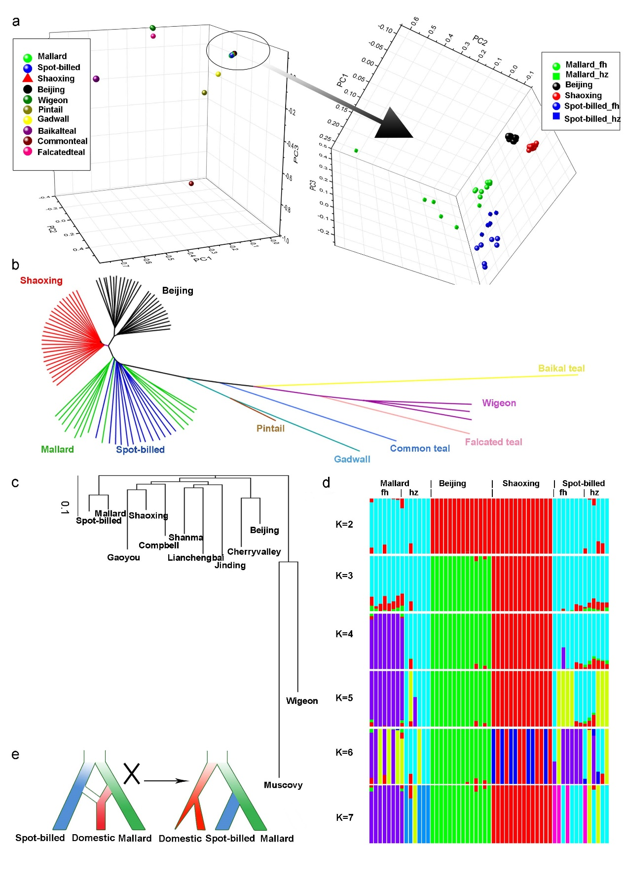Figure 1: Inference of phylogenetic topology in wild and domestic ducks. Beijing and Shaoxing ducks representing domestic ducks were used the Principal Component Analysis (PCA), phylogenetic analysis based on identity-by-state (IBS) and genetic structure analyses. “_fh” and “_hz” mean spot-billed and mallard collected from Fenghua and Hangzhou respectively. (a) PCA plot constructed for Principal Component 1 (PC1), PC2 and PC3 using 10,525 high-quality filtered SNPs from 27 Beijing and 27 Shaoxing ducks and 35 wild ducks (one bailkal teal, one gadwall, one pintail one falcated teal, common teal, three wigeon, 13 spot-billeds and 14 mallards) shows that domestic ducks are close to spot-billed and mallard wild ducks. (b) Neighbor-joining tree based on IBS distance of 80,505,576 SNPs. (c) Neighbor-joining tree based on genome wide pairwise fixation index (F_{ST}) of 44,852,612 SNP. (d) Genetic structure analyses of 13 spot-billed and 14 mallard wild ducks, together with 14 Beijing and 14 Shaoxing domestic ducks, using admixture ranging K from two to seven. (e) The inferred demographic models for wild and domestic ducks inferred based on genetic analysis of a-d (right). The traditional demographic model, hypothesized that domestic ducks were originated from mallard or the descendant of a mixture of spot-billed and mallard (left) are incompatible with observations in neighbor-joining trees (b-c) and genetic data(d).
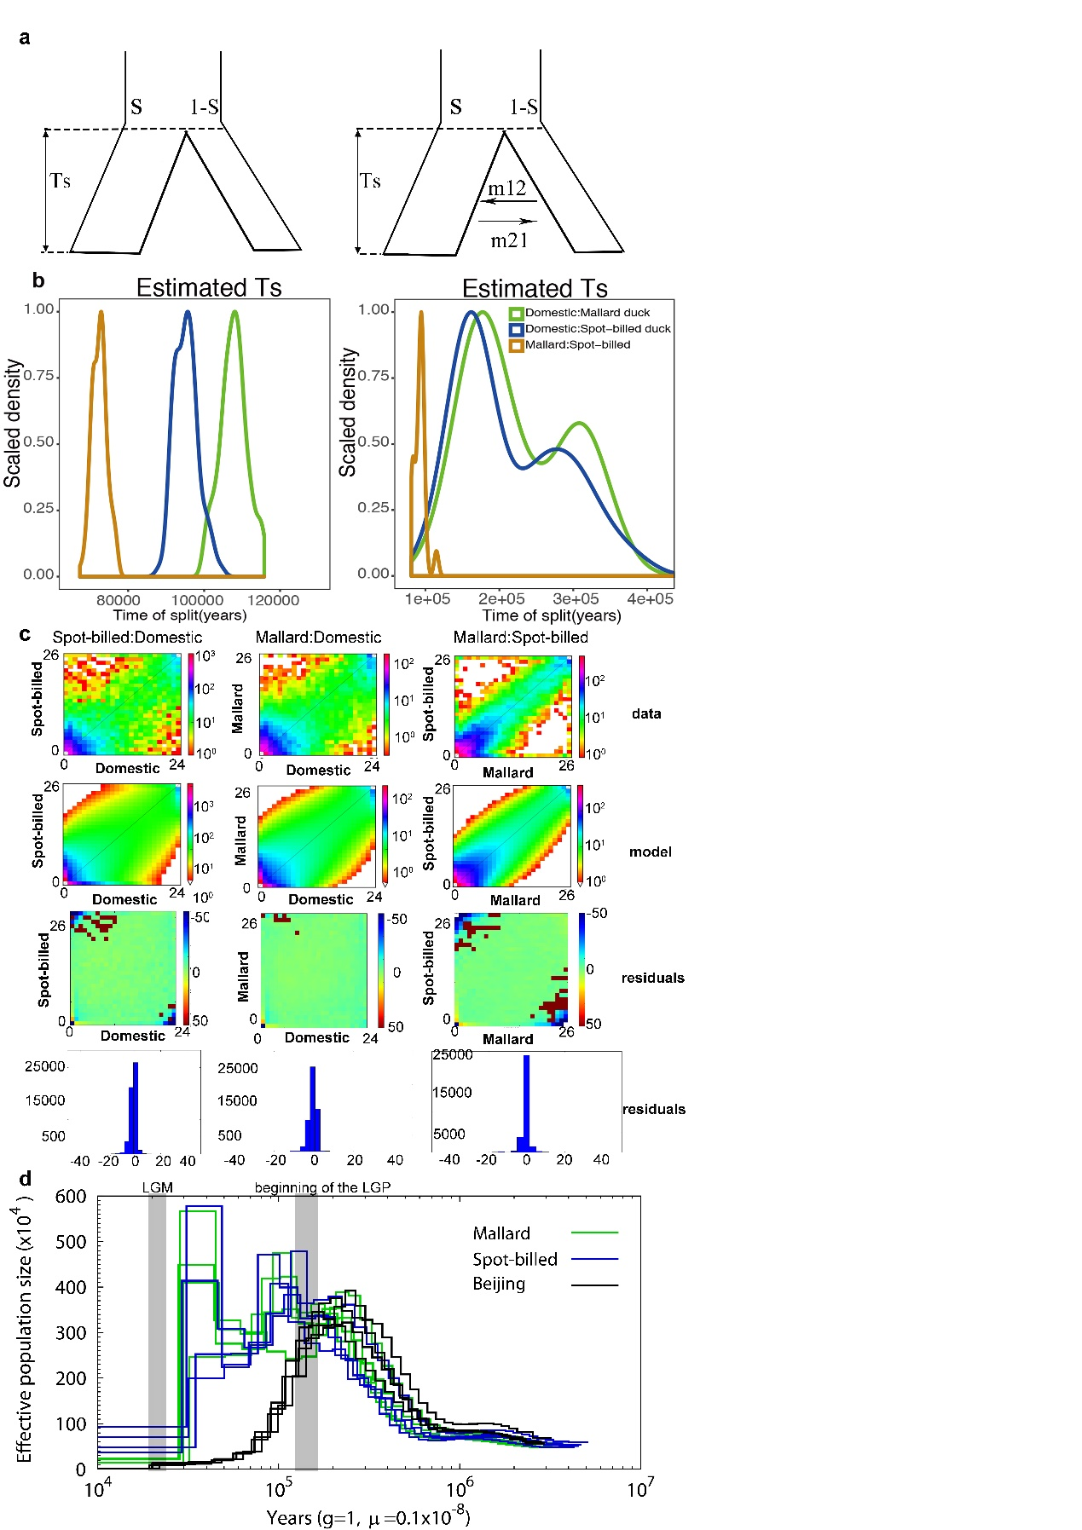
Figure 2: Inference of joint demographic history of ducks. Wild ducks included spot-billed and mallard ducks. Domestic ducks included Beijing, Cherryvalley, Compbel, Gaoyou, Jingding, Lianchengbai, Shaoxing and Shanma. (a) Illustration of the two models (with/without migration) used in the history inference through the $∂$a$∂$i analysis. Parameters corresponding to the code that were provided in supporting information. (b) Distribution of estimate Ts (divergence time) of each model in 100 simulations between spot-billed and mallard (orange), mallard and domestic lineage (green), spot-billed and domestic lineage (blue), respectively. (c) Joint Site Frequency Spectrum (SFS) for observed data, simulation data and residuals. (d) Demographic history inference of mallard duck, spot-billed duck and Beijing duck through the PSMC analysis.
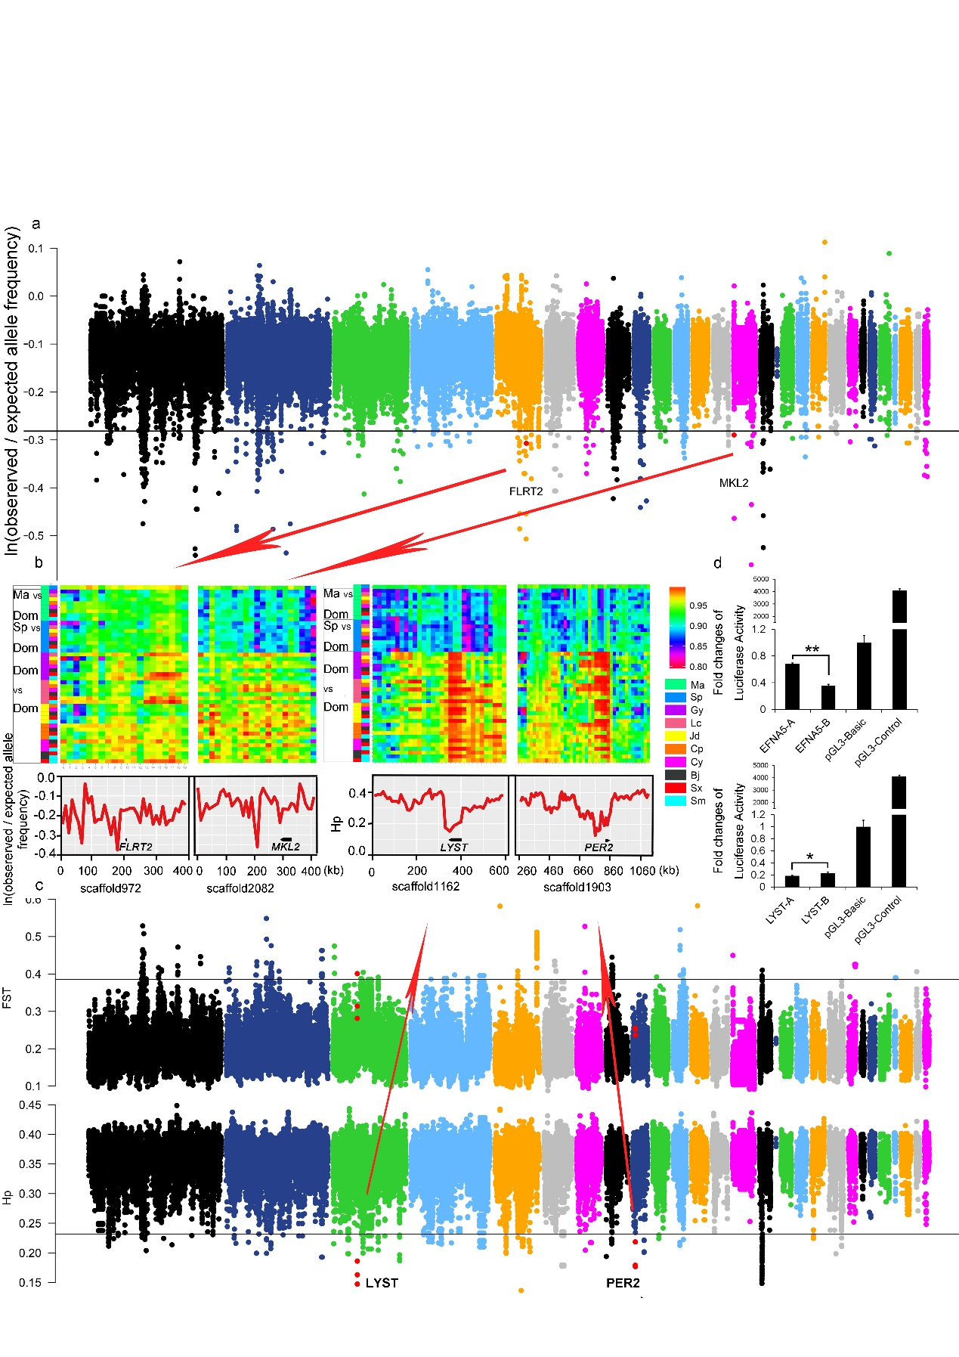Figure 3: Summary of selective sweep analyses of the early wild duck lineage and domestic duck. (a) Distribution of ln(observed/expected derived allele frequency) that is calculated in 20 kb window with a sliding size of 10 kb along scaffolds that is arranged according to their alignment to the chicken autosomes. The horizontal black line indicates the threshold at ln(observed/expected derived allele frequency) = -0.3136 (mean of ln values - 4 standard deviations). Outlier regions that were detail visualized by identity scores (IS) and re-computing values in more smaller window size in (b) were highlight with red dots. (b) Details of four putative selective sweep regions around the FLRT2, MKL2, LYST and PER2 genes. Upside of each panel shown degree of haplotype sharing in pairwise comparisons among populations. Color boxes (left) indicate the comparison performed on that row. “Ma”, “Sp”, “Dom”, represent mallard, spot-billed and domestic duck respectively. Y-axis (downside) of FLRT2,MKL2, which is associated with retina/heart morphogenesis that were under seletion in wild ancestor, are ln(observed/expected derived allele frequency), whereas y-axis of LYST,PER2 that were under selection in domestic duck are hp. (c) Distribution of F_{ST} between the wild and the domestic duck, and Hp in the domestic duck that is calculated in 40 kb with a sliding size 20 kb along scaffolds that is arranged according their alignment to the chicken autosomes. The horizontal black line indicates the threshold at F_{ST} = 0.3858 or Hp=0.2319 (mean of ln values - 4 standard deviations). Red dots indicate the location of outlier genes (4 standard deviations away from hp means) that were detail visualized in (b). (d) Comparison in luciferase activity of major alleles of MRPS27 and EFNA5 in wild (spot-billed and mallard) and domestic (Beijing) duck in DF1 (chicken embryonic fibroblast) cells. “A” and “B” represent wild duck and domestic duck, respectively. “*” P ≤ 0.05.
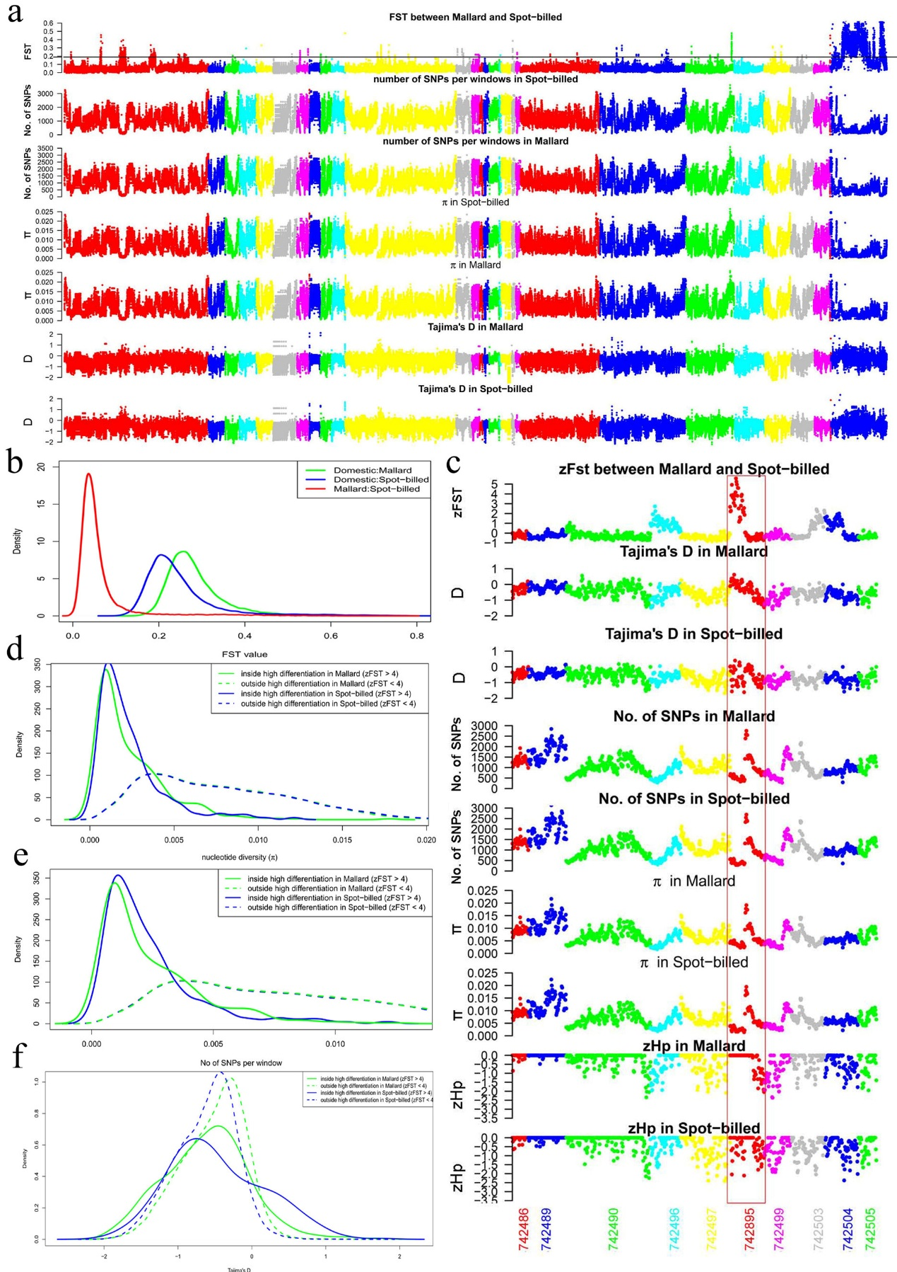Figure 4: The genomic landscape of species divergence between spot-billed and mallard ducks. (a) Distribution of population genomic parameters of the Beijing duck assembly, in 40 kb windows sliding 20 kb steps. The blue scaffolds in the right were referred as duck Z scaffolds. The black horizontal line indicates the threshold at F_{ST} = 0.1888 (mean of F_{ST} + 4 standard deviations, referred it as Z(F_{ST}) = 4). The plots show the F_{ST} between spot-billed and mallard, number of SNPs per window, nucleotide diversity (π), Tajima’s D for spot-billed and mallard respectively. (b) Distribution of pairwise F_{ST} for 40 kb windows sliding 20 kb steps. The red line shows the plot in the first row of (a). The blue and green line show the pairwise F_{ST} between spot-billed/mallard and domestic ducks (combination of 8 domestic breeds). (c) Distribution of population genomic parameters along ten scaffolds. (d-f) Distribution of nucleotide diversity (π), number of SNPs per window and Tajima’s D inside/outside high differentiation regions in Beijing duck assembly.
Tables
Table 1. Comparison in features of the mallard, spot-billed and Beijing duck
genomes
Genomic features | Mallard | Spot-billed | Beijing duck
Assembled genome size (Gb) | 1.27 | 1.31 | 1.11
Contig N50 (bp) | 38,271 | 33,061 | 26,114
Scaffold N50 (bp) | 2,489,142 | 2,054,876 | 1,233,631
GC content (%) | 41.90 | 41.90 | 40.90
Repeat rate (%) | 10.71 | 10.55 | 7.31
Heterozygosity rate (×10⁻³) | 3.60 | 3.54 | 2.40
Predicted protein-coding genes | 21,056 | 21,123 | 20,629

Table 2. Top 32 enriched biological process terms among genes under positive selection in the early spot-billed and mallard ancestors
Gene ontology term | P-value | Number | Size
positive regulation of tyrosine phosphorylation of Stat3 protein | 6.29E-05 | 4 | 12
regulation of activin receptor signaling pathway | 0.000382 | 2 | 2
positive regulation of cytosolic calcium ion concentration involved in phospholipase C-activating G-protein coupled signaling pathway | 0.000387 | 3 | 8
detection of virus | 0.001131 | 2 | 3
D-aspartate import | 0.001131 | 2 | 3
metanephros morphogenesis | 0.002232 | 2 | 4
L-glutamate import | 0.002232 | 2 | 4
negative regulation of extrinsic apoptotic signaling pathway in absence of ligand | 0.003441 | 3 | 16
positive regulation of granulocyte macrophage colony-stimulating factor production | 0.003672 | 2 | 5
respiratory system development | 0.003672 | 2 | 5
determination of left/right symmetry | 0.003701 | 5 | 53
spinal cord motor neuron differentiation | 0.004119 | 3 | 17
lung morphogenesis | 0.004119 | 3 | 17
ionotropic glutamate receptor signaling pathway | 0.004872 | 3 | 18
ventricular cardiac muscle tissue morphogenesis | 0.004872 | 3 | 18
dorsal/ventral pattern formation | 0.005176 | 4 | 36
negative regulation of peptidyl-threonine phosphorylation | 0.005437 | 2 | 6
serotonin metabolic process | 0.005437 | 2 | 6
lung epithelium development | 0.005437 | 2 | 6
cytokine-mediated signaling pathway | 0.006291 | 4 | 38
nucleotide-excision repair | 0.006613 | 3 | 20
neutrophil chemotaxis | 0.006613 | 3 | 20
negative regulation of epithelial cell proliferation | 0.006904 | 4 | 39
positive regulation of heart rate | 0.007514 | 2 | 7
inositol phosphate-mediated signaling | 0.007514 | 2 | 7
bud elongation involved in lung branching | 0.007514 | 2 | 7
limb morphogenesis | 0.009839 | 3 | 23
long-chain fatty acid metabolic process | 0.00989 | 2 | 8
dicarboxylic acid transport | 0.00989 | 2 | 8
interleukin-6-mediated signaling pathway | 0.00989 | 2 | 8
thrombin receptor signaling pathway | 0.00989 | 2 | 8
response to wounding | 0.012416 | 3 | 25
Full lists of enriched terms are presented in Table S15. Terms that considered to be associated with enhancement of long range flight ability were in bold. Size represents total number genes of this term.

